**PeopleSoft Inventory - Setups and Transactions**

Contents

1. Global Installation Options 3

2. Item Configuration Setups Required for PeopleSoft Inventory 4

3. Inventory Setup 9

4. Setting Up Inventory Fulfillment Options 17

5. Setting Up Material Storage Locations 19

6. Item Setup Revisited 21

7. Defining Item Putaway to Inventory 25

8. Creating an Item Putaway transaction 27

9. Intra-Unit Inventory Transfers 32

10. Inventory Adjustments 33

11. Taking Inventory Counts 34

# Global Installation Options

Inventory Checked at Installation Level

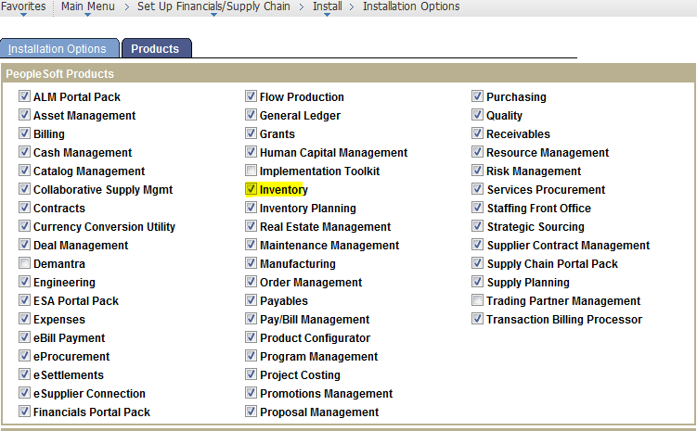

Installation Options for PeopleSoft Inventory

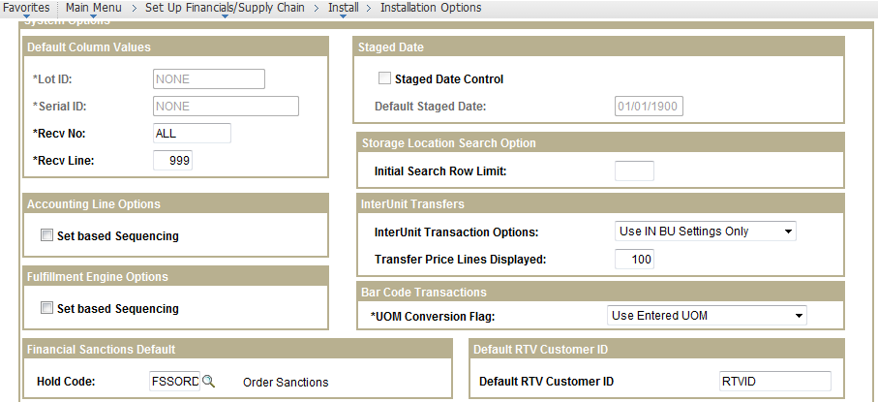

User Preferences for Inventory

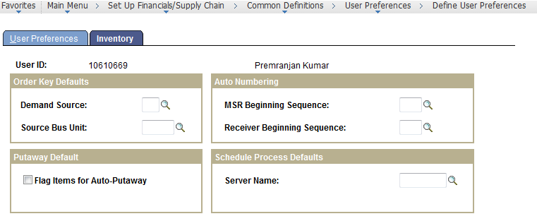

# Item Configuration Setups Required for PeopleSoft Inventory

Cost Books

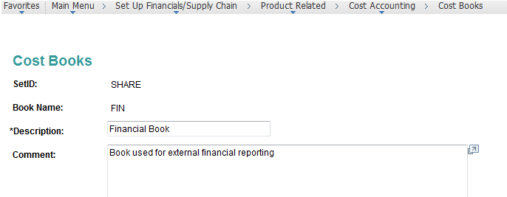

Cost Profiles

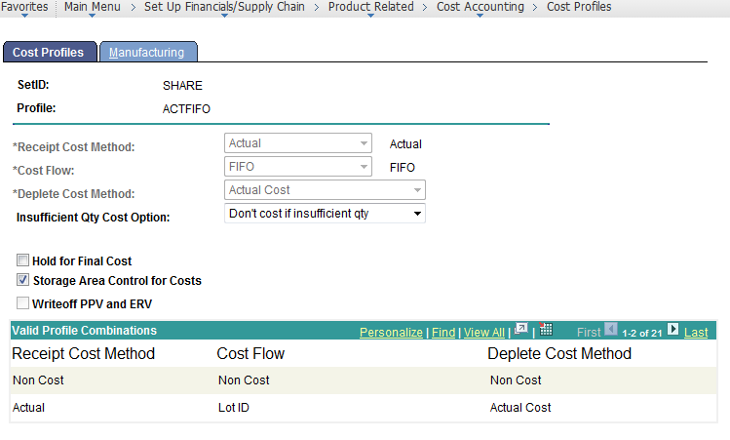

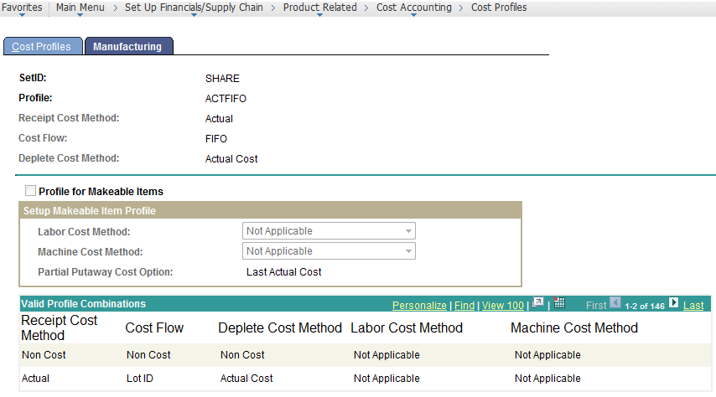

Cost Types

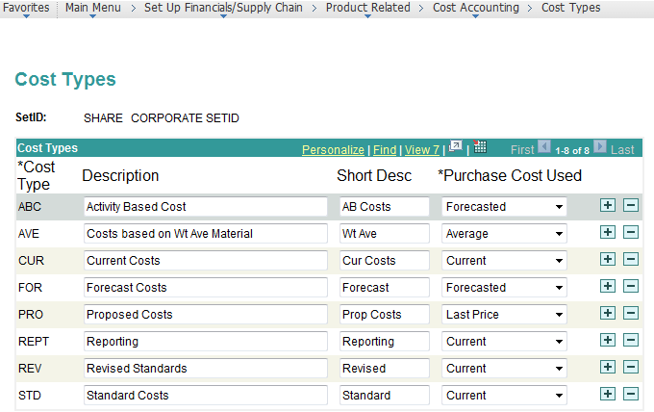

Cost Elements

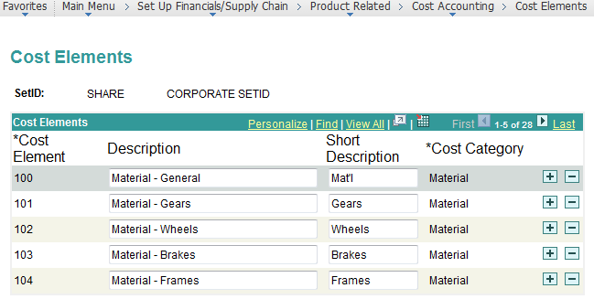

Create Item

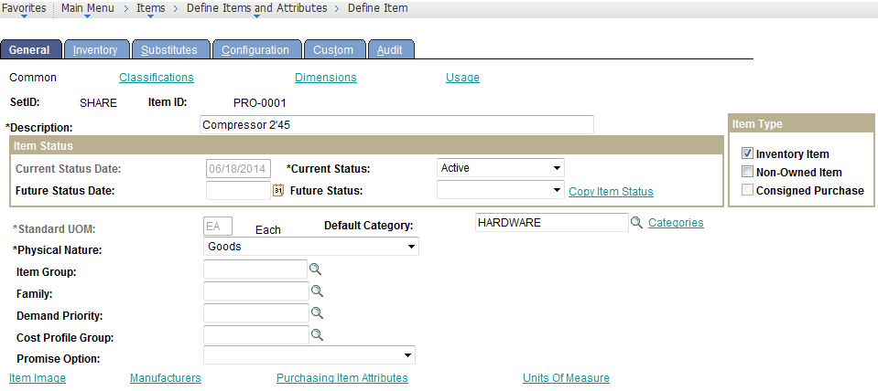

Inventory Tab

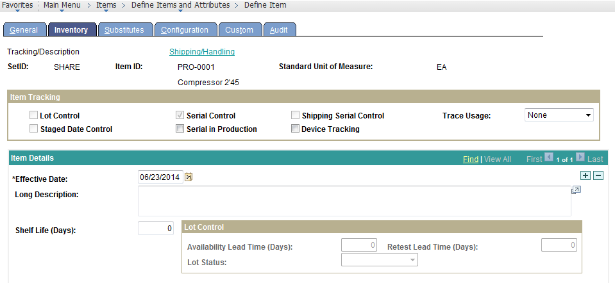

Item Purchasing Attributes

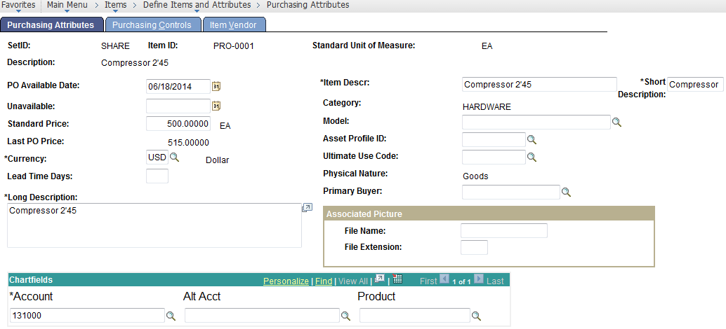

Item Vendor Relationships

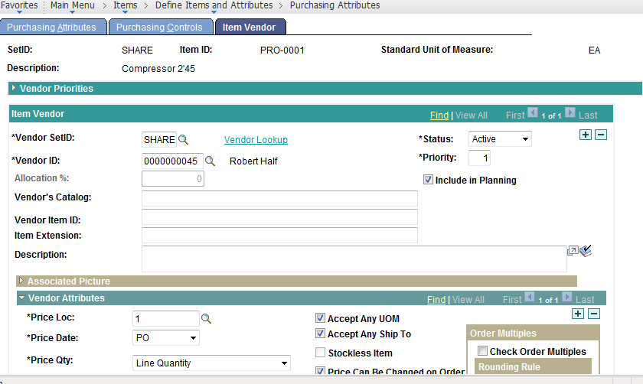

# Inventory Setup

Inventory Types – Used to Categorize Inventory Business Units. Examples Could be: Cold Storage Facility, Distribution and Cross Docking Centre, Bulk Material Storage Facility etc

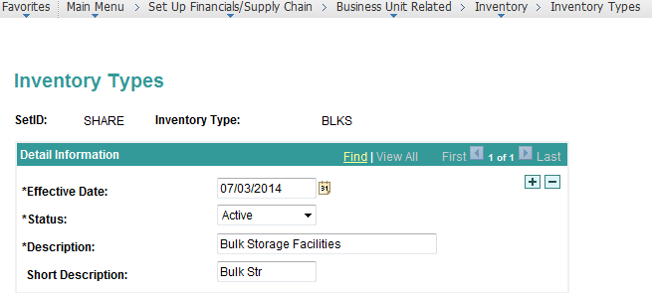

Inventory Groups

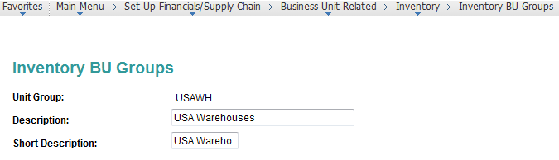

Business Unit Definition

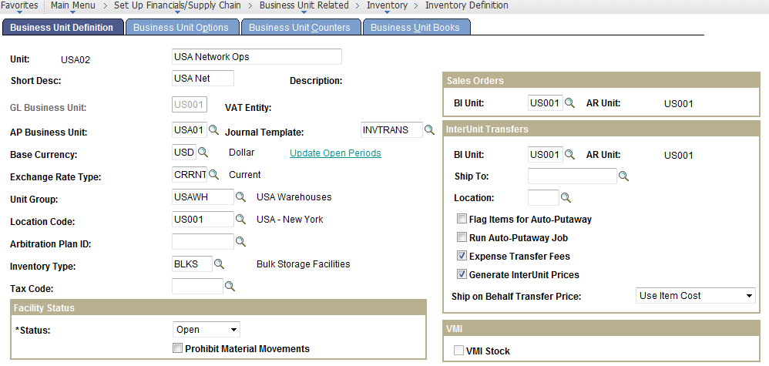

Business Unit Definition-II

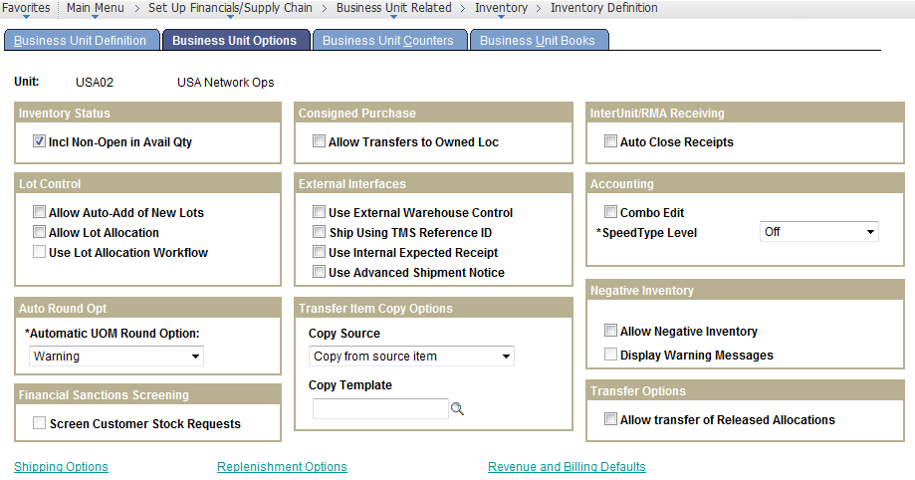

Business Unit Definition-II

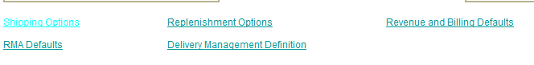

Business Unit Definition-III

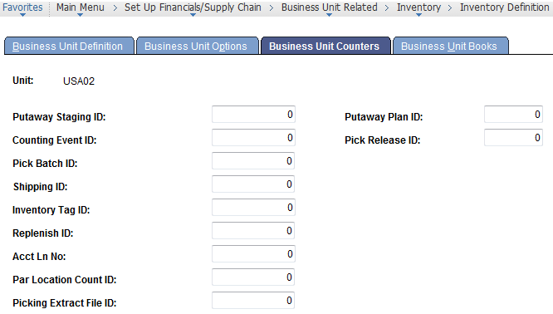

Business Unit Definition-IV

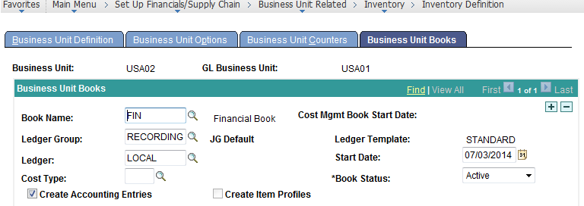

Business Unit Definition-V

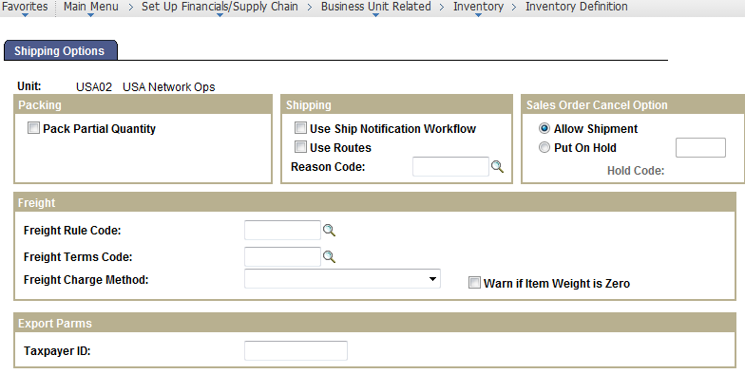

Business Unit Definition-VI

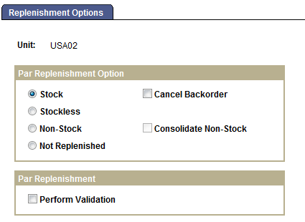

Business Unit Definition-VII

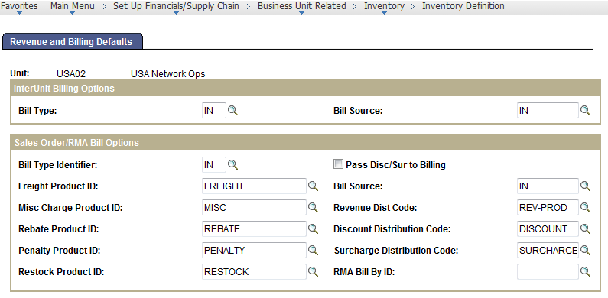

Business Unit Definition-VIII

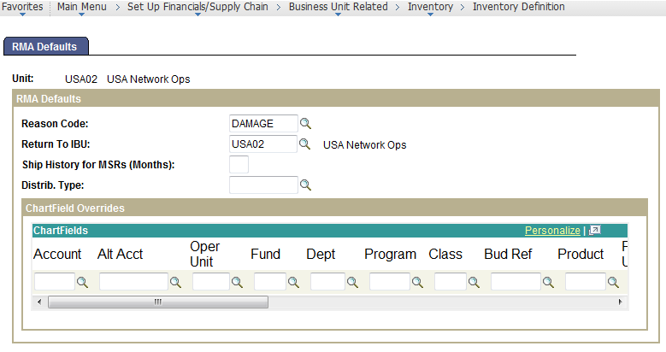

Business Unit Definition-IX

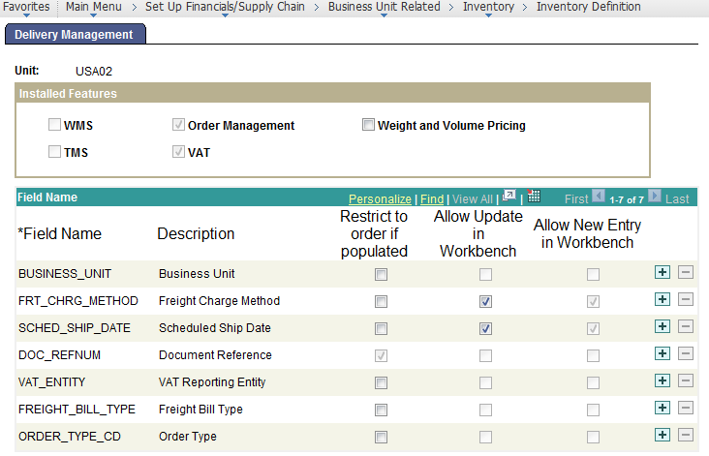

Inventory Display Options

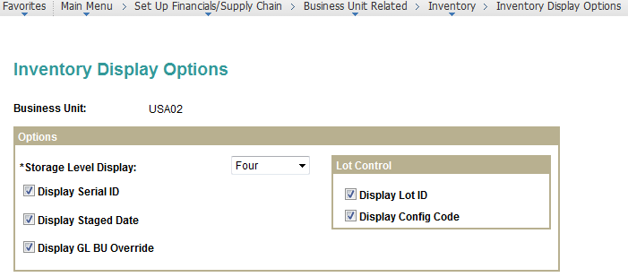

Inventory Options- Specific to the SETID

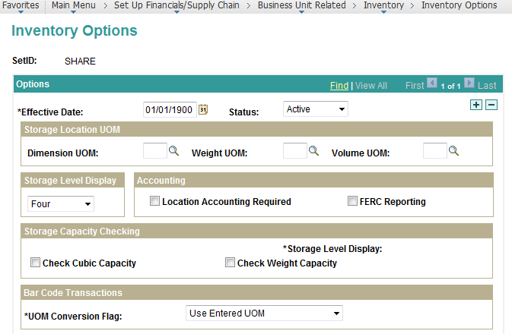

Priority Rules Setup

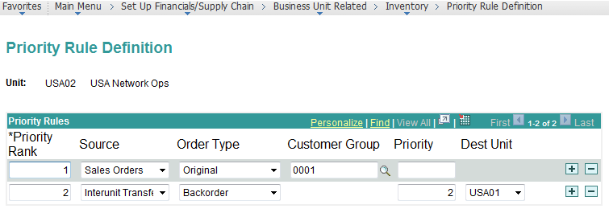

Closure Calendars:

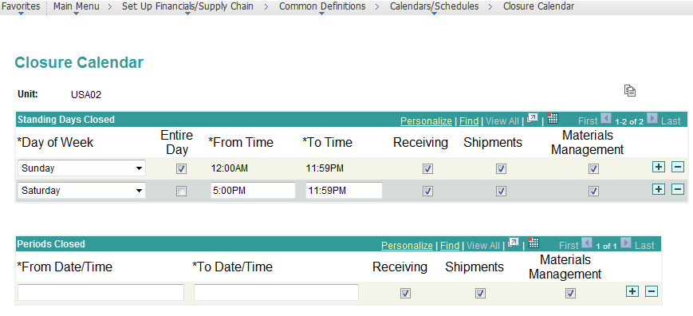

# Setting Up Inventory Fulfillment Options

Fulfillment Engine Options – I

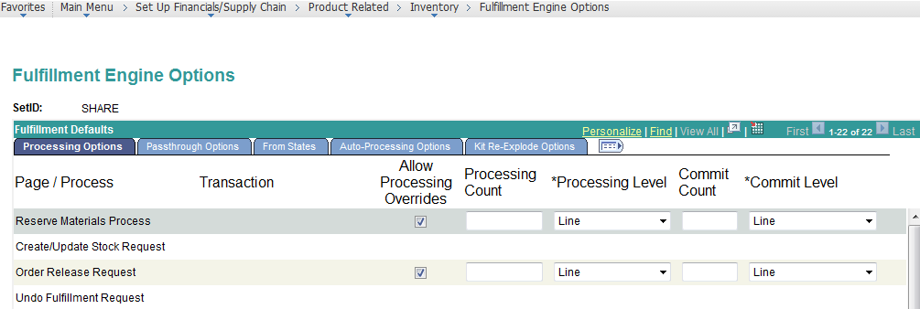

Fulfillment Engine Options – II

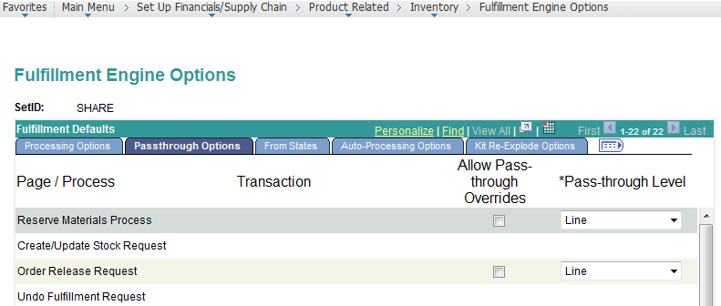

Fulfillment Engine Options – III

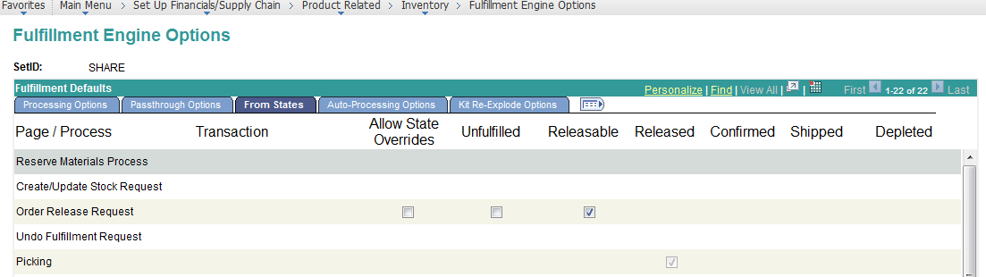

Fulfillment Engine Options – IV

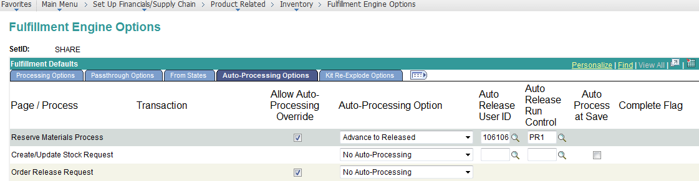

Fulfillment Engine Options – V

|  |  |
| --- | --- |
| **Page/ Process** | **Transaction** |
| Reserve Materials Process |  |
| Create/Update Stock Request |  |
| Order Release Request |  |
| Undo Fulfillment Request |  |
| Picking |  |
| Material Picking Feedback |  |
| Picking Confirmation |  |
| Front-end Shipping Requests |  |
| Express Issue |  |
| Shipping Requests |  |
| Shipping/Issues |  |
| Deplete On Hand Quantity |  |
| Kit Re-Explode |  |
| Fulfillment Workbench | Request to Reserve |
| Fulfillment Workbench | Request Picking Feedback |
| Fulfillment Workbench | Request to Ship (front-end) |
| Fulfillment Workbench | Request to Ship |
| Transactions | Create Stock Request |
| Transactions | Request to Reserve |
| Transactions | Request Picking Feedback |
| Transactions | Request to Ship (front-end) |
| Transactions | Request to Ship |

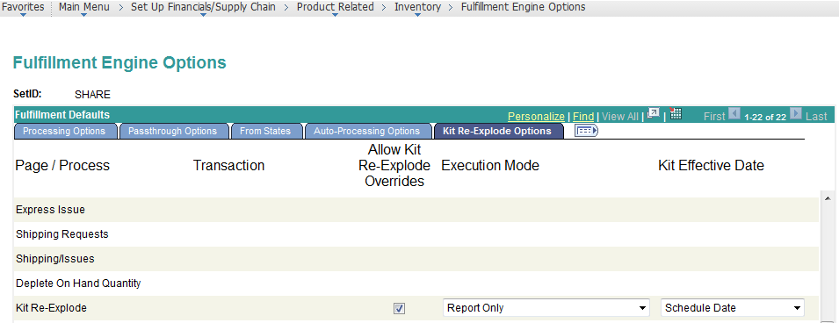

# Setting Up Material Storage Locations

Storage Location Types

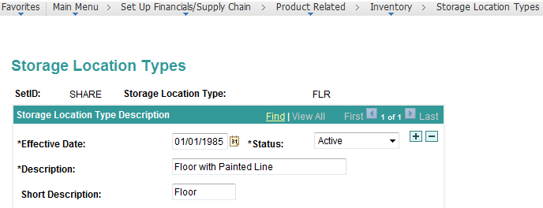

Storage Zone Codes

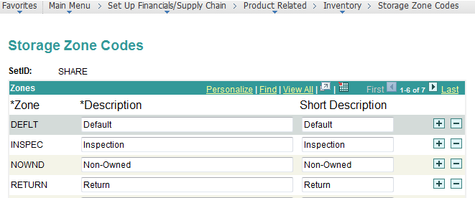

Container Types –

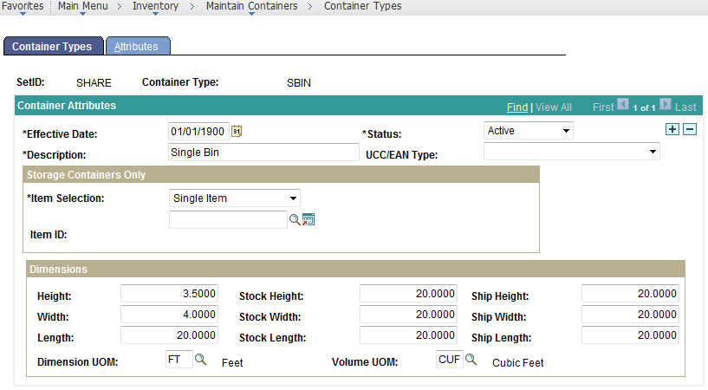

Warehouse Storage Area

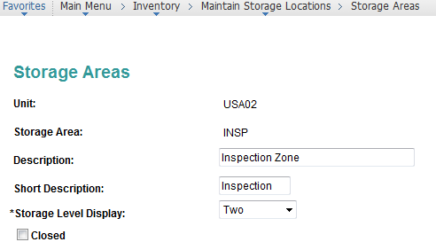

Material Storage Locations

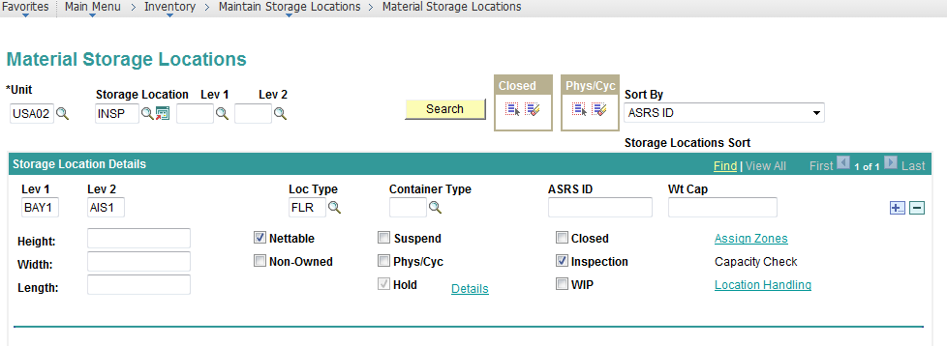

# Item Setup Revisited

Create Business Unit Item

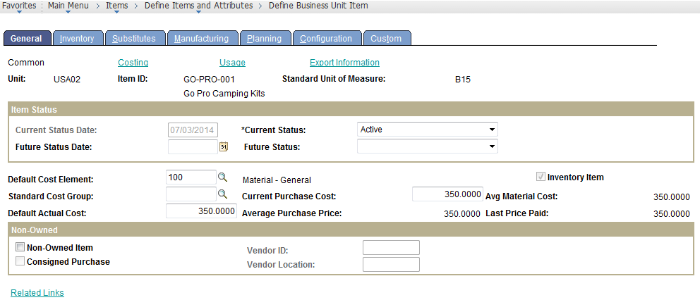

Update the Costing Profile.

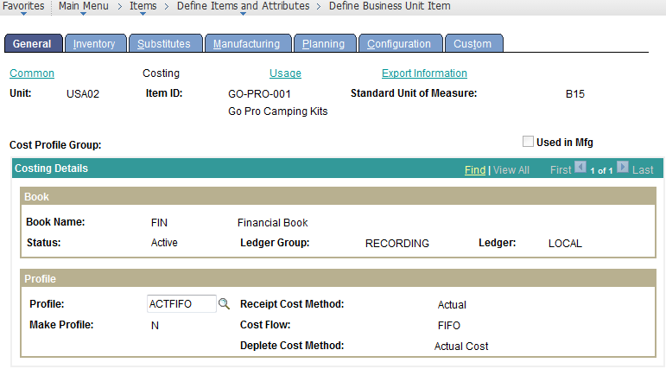

Source Code of the Item Specifies Whether it’s a Buy Item or a Make Item.

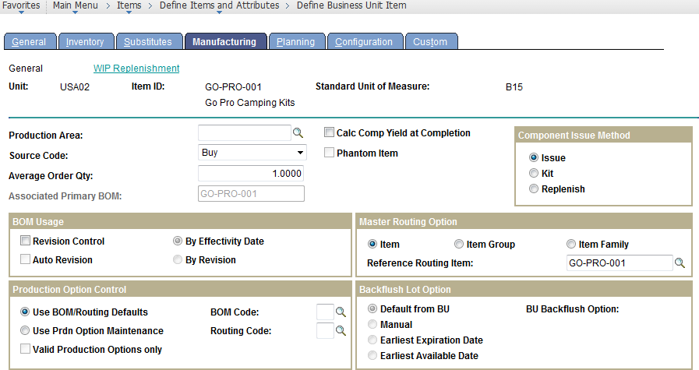

Create Cost Version

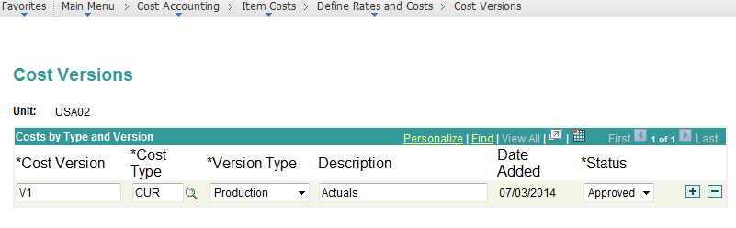

Run the Cost Rollup Process

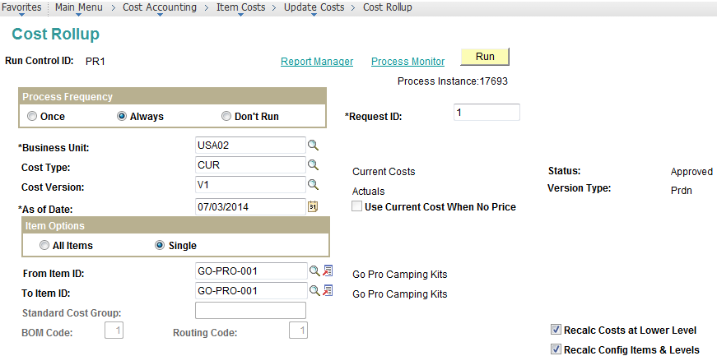

Run the Cost Update and Inventory Revaluation Process

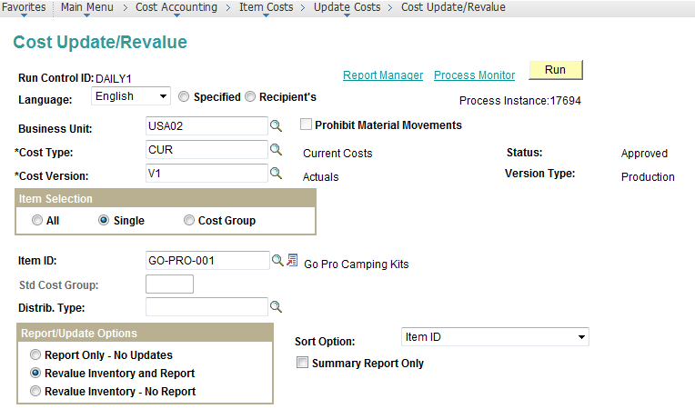

# Defining Item Putaway to Inventory

Define Business Unit Putaway Parameters

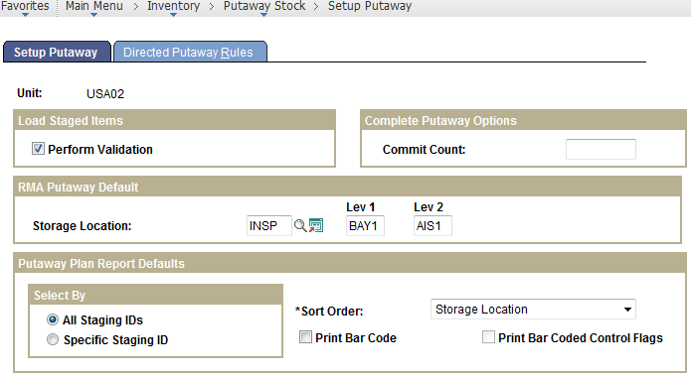

Directed Putaway Rules

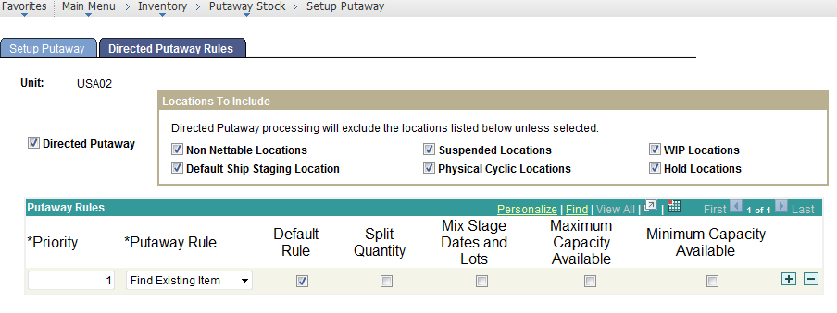

Setup Transaction Accounting Rules

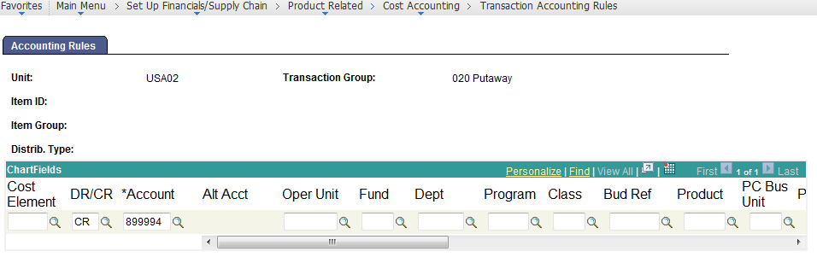

Setup Storage Area Accounting

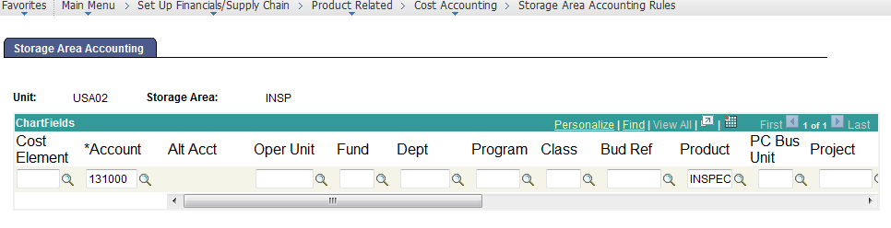

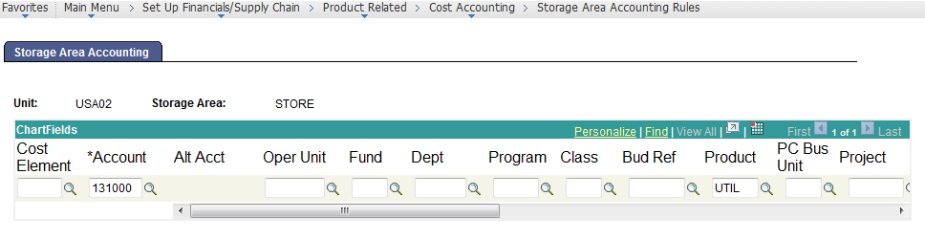

# Creating an Item Putaway transaction

Create a Material Receipt

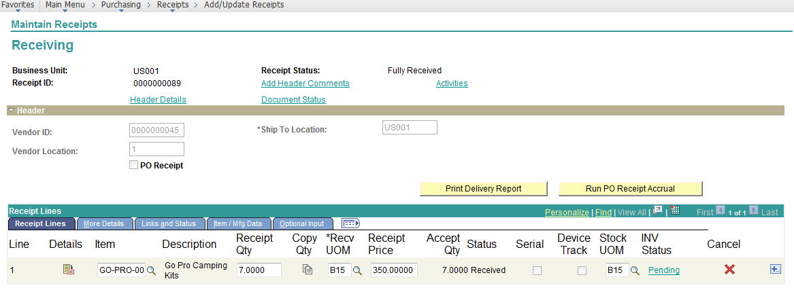

Inventory Business Unit to Which the Material is Stored.

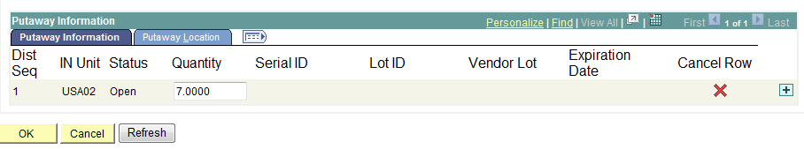

Optionally assign the putaway location at the receipt, or else the System Calculates the Putaway Location based on Defaults/ Directed Putaway.

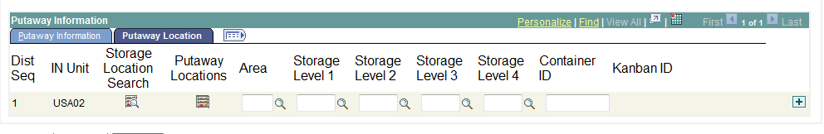

Run the Receipt to Inventory Push Process

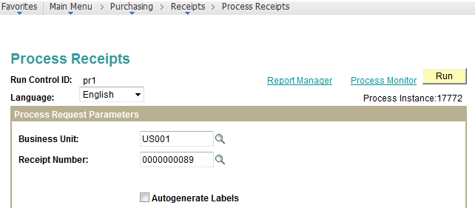

Run the Putaway Plan Report

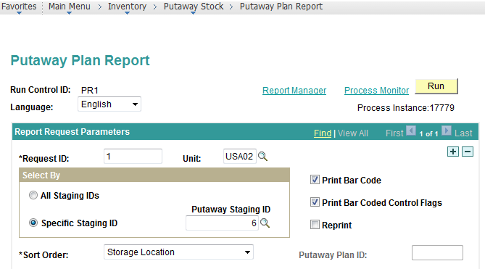

Generates an Output as Following

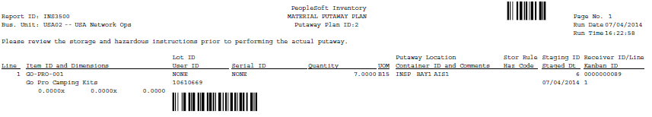

Provide Stockroom Feedback for Putaway Completion

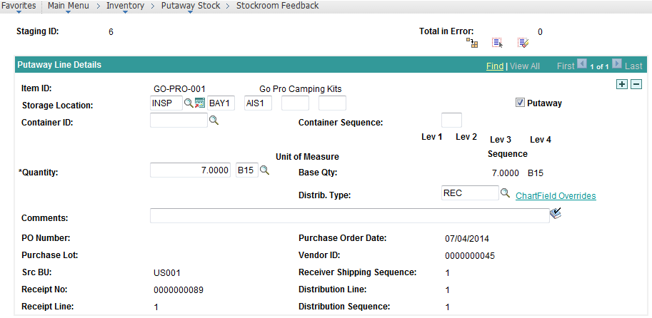

Complete Putaway Processing.

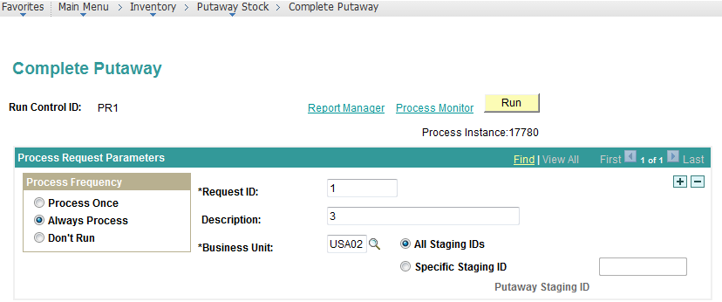

Moves the Material to the Available Inventory

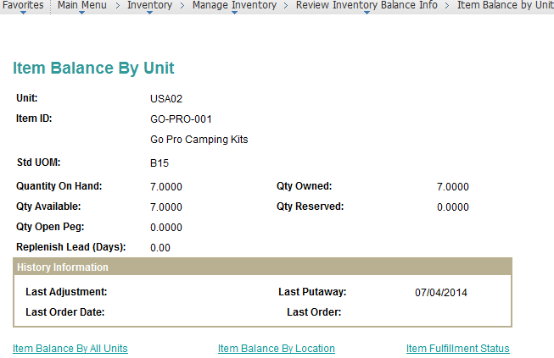

Run Cost Accounting Creation Job.

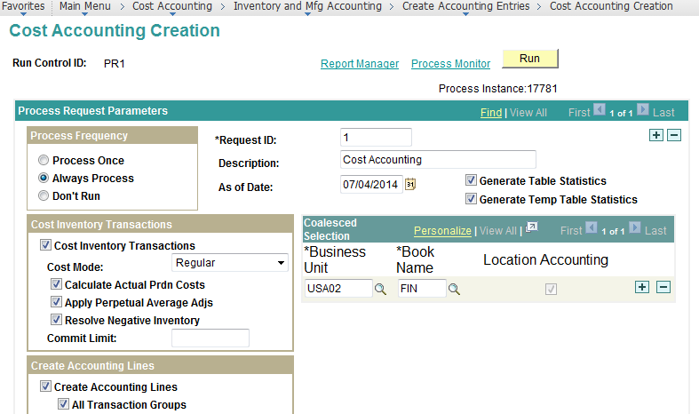

Accounting Entries Generated

SELECT A.BUSINESS_UNIT, A.TRANSACTION_GROUP, TO_CHAR(A.ACCOUNTING_DT,'YYYY-MM-DD'), A.ACCTG_LINE_NO, A.CM_BOOK, A.DISTRIB_TYPE, A.COST_ELEMENT, A.ACCOUNT, A.PRODUCT, A.CURRENCY_CD, A.MONETARY_AMOUNT, A.INV_ITEM_ID, A.RECEIVER_ID, A.GL_DISTRIB_STATUS, A.PC_DISTRIB_STATUS   
  FROM PS_CM_ACCTG_LINE A   
  WHERE ( A.BUSINESS_UNIT = 'USA02'   
     AND A.RECEIVER_ID = '0000000089' )

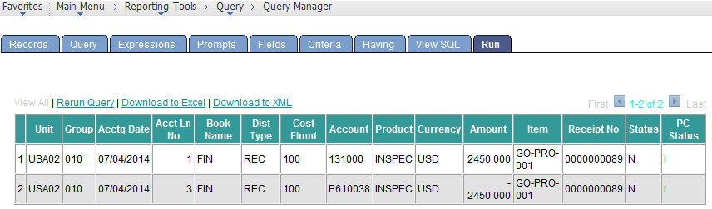

Review the Inventory On Hand Value

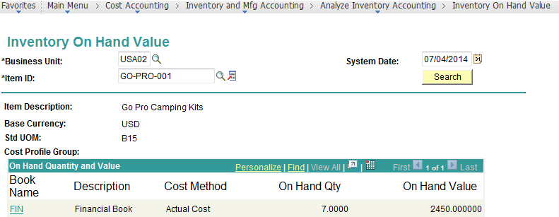

# Intra-Unit Inventory Transfers

Navigate to the Inventory Transfer Screen

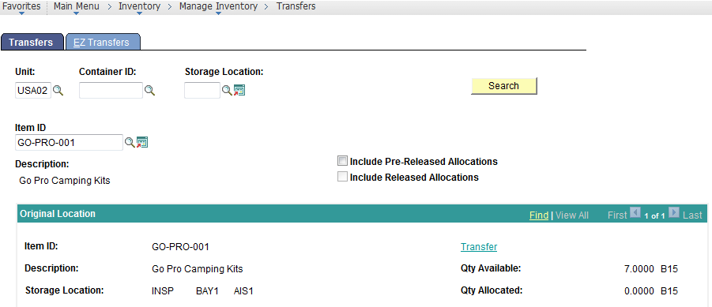

Specify the New Location and Save.

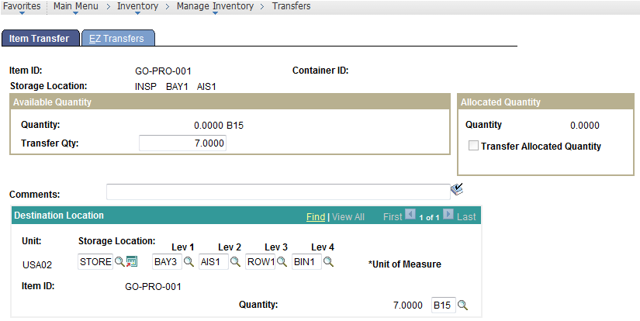

Accounting Entries Generated after Accounting Run

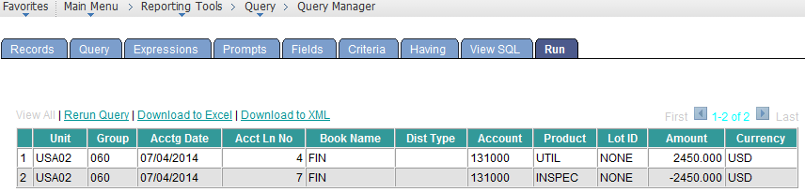

# Inventory Adjustments

Complete Inventory Adjustments

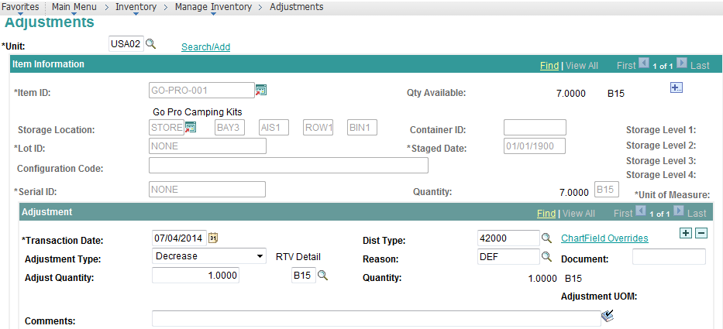

# Taking Inventory Counts

Setup Utilization Groups

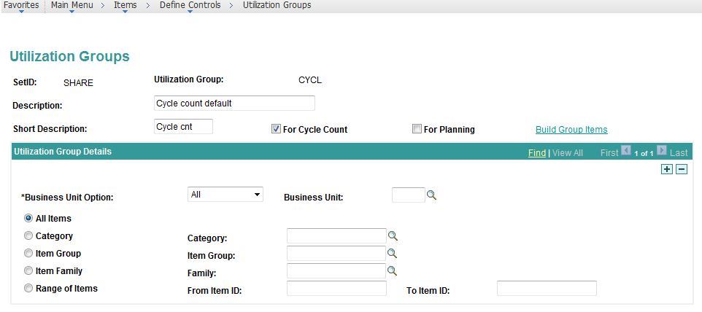

Setup Utilization Types

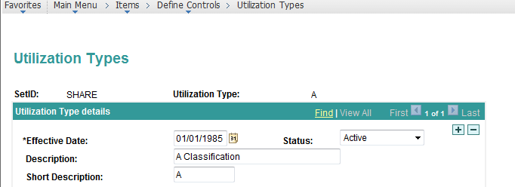

Associate Utilization Type to the Material on the Business Unit Item Page.

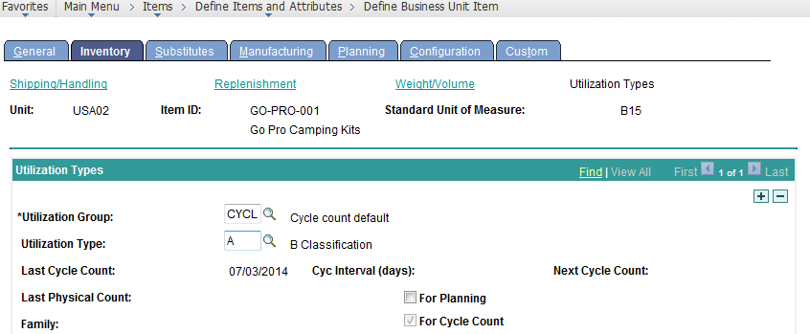

Setup Inventory Count Policy for the Business Unit

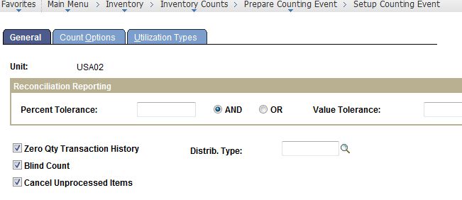

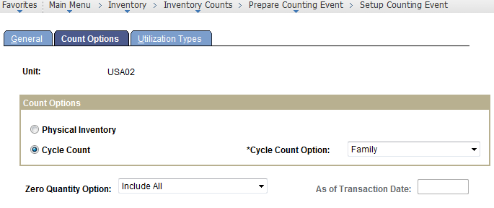

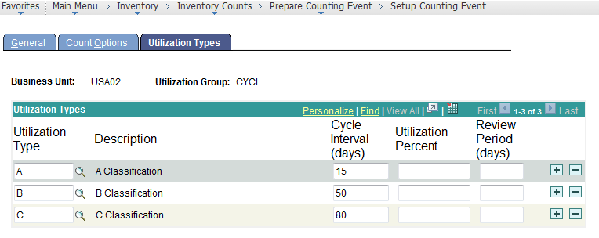

Run the Cycle Count Event Creation Job

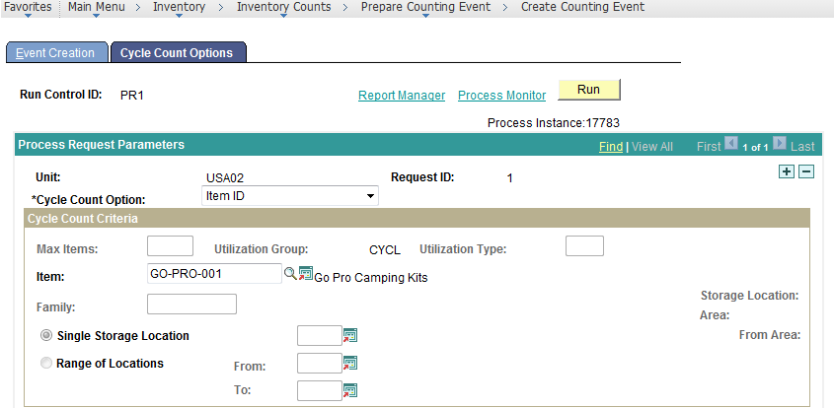

Create Counting Sheet

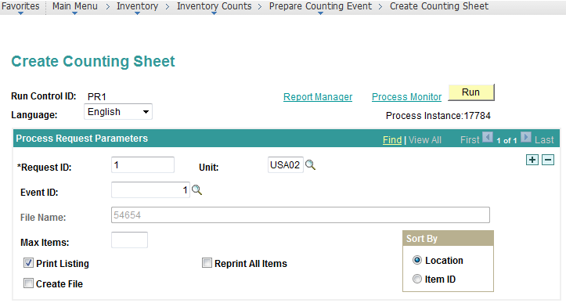

Generates Counting Sheet

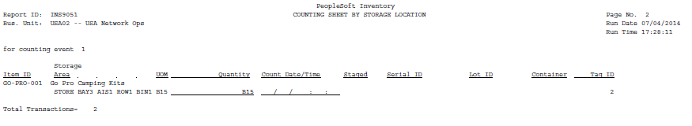

Update Item Stock Values

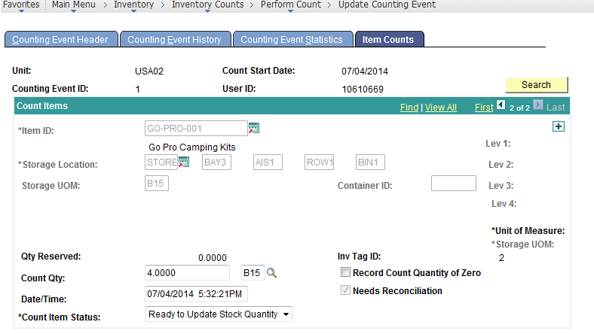

Run the Reconciliation Report

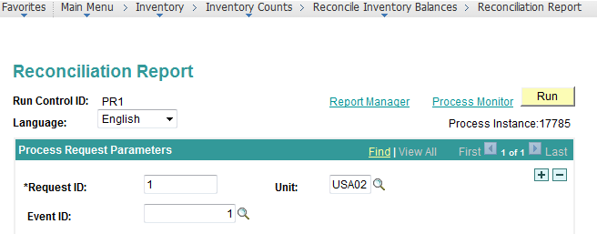

Generates Reconciliation Report

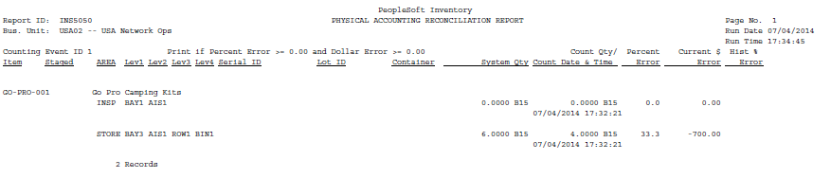

Update the Stock Quantity

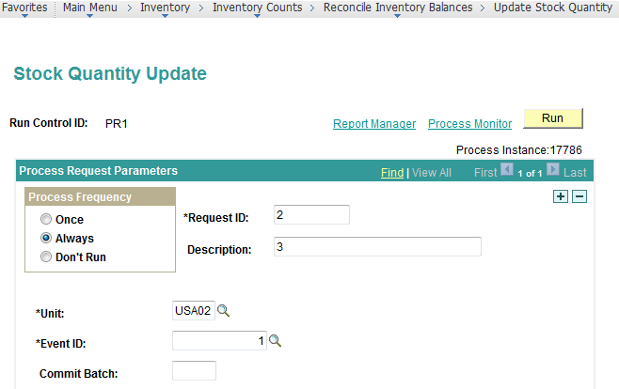

Item Balance gets Updated

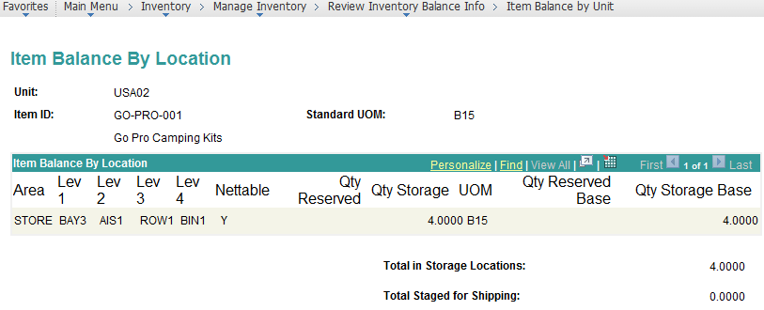

Updates the Item Cycle Count Date, Next Count Date on the Item.

